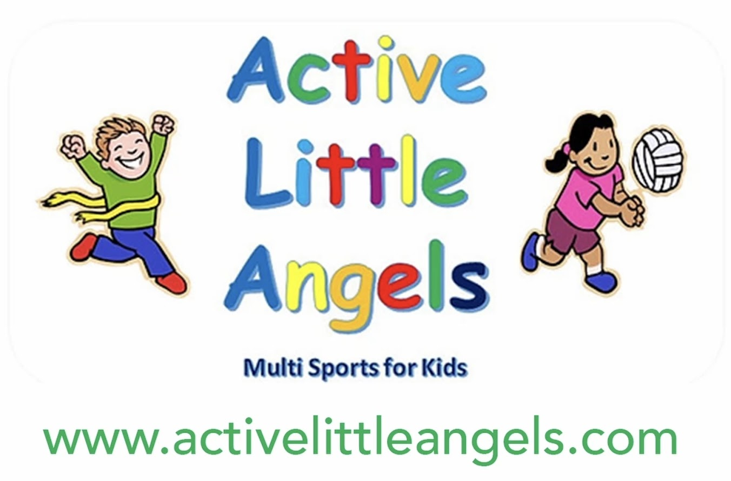

Active Little Angels

Child Protection Policy for Active Little Angels
Introduction:
At Active Little Angels, we are committed to ensuring the safety and well-being of all children who participate in our activities. This policy outlines the steps we take to safeguard children, prevent abuse, and ensure that all staff, volunteers, and parents are aware of their responsibilities in this regard.
Purpose:
The purpose of this policy is to:
- Safeguard children from harm.
- Promote a safe and positive environment in which children can enjoy sport and physical activities.
- Ensure that all staff, volunteers, and parents understand their roles in protecting children from harm.
- Provide guidance on how to respond to allegations or concerns regarding child protection.
Scope:
This policy applies to all staff, volunteers, and parents involved in Active Little Angels activities, including coaches, assistants, and any other individuals who may come into contact with children.
Key Principles:
- The Welfare of the Child is Paramount: The safety and well-being of children is our primary concern. All decisions will be made with this in mind.
- Respect for Children: All children have the right to be treated with respect, kindness, and dignity. We will always ensure that children are listened to and their voices are heard.
- Zero Tolerance for Abuse: We have a zero-tolerance approach to any form of abuse, neglect, or harm towards children.
- Safe Environment: We will ensure that the environment in which children participate in sports is safe, secure, and appropriate for their developmental needs.
- Children in our care: We will always try to have at least 2 staff members with the children at all times. Will will strive to prevent a situation where a child/ children are alone with only one staff member.
- Assisting our young participants. If any child needs assistance whilst going to the toilet, with nappy changes, with changing of clothes, there will always be 2 staff members in attendance and permission will have been granted by the child’s parent/ guardian when signing up.
- Safe drop off and collection: The Lead coach will sign all participants in and out at the start and end of each Active Little Angels session. The children will only be allowed to leave with their parents/ guardians who are known to Active Little Angels, unless the parents/ guardians have given Active Little Angels notice of an alternative individual for collection including description and code word to be used.
- Caring for a child in the event of a missed collection: When a child doesn’t get collected on time, the parent/ guardian will be called. At least 2 members of staff will stay with the child unless the parent/ guardian gives permission for 1 member of staff to stay with the child.
Key Responsibilities:
- Staff and Volunteers: All staff and volunteers working with children will undergo appropriate background checks (such as DBS checks) and be educated in our child protection and safeguarding policies. They will be familiar with these policies and follow them at all times.
- Parents and Guardians: Parents and guardians play a key role in safeguarding their children. We encourage open communication between parents, staff, and volunteers to ensure a shared understanding of how to keep children safe.
- Children’s Rights: We will educate children about their right to be safe, the importance of speaking up if they feel uncomfortable or unsafe, and the appropriate actions they can take if they have concerns.
Staff Code of Conduct:
- All staff and volunteers will model good behavior and treat all children with kindness, respect, and fairness.
- Physical contact will only occur when it is necessary for the child’s safety or as part of the sport (e.g., guiding a child during an activity). We always seek to minimize physical contact and avoid unnecessary or prolonged contact.
- Staff and volunteers will never engage in any behavior that could be perceived as abusive, including:
  - Bullying, intimidation, or discrimination.
  - Engaging in inappropriate conversations with children.
  - Sharing personal information with children outside the scope of the program.
Procedures for Reporting Concerns:
If any staff member, volunteer, parent, or child has concerns about the welfare of a child, they must report it immediately to the designated safeguarding lead (DSL). The DSL (Head coach) will be responsible for managing and investigating the concern according to safeguarding protocols.
The procedure for reporting concerns includes:
- Immediate Action: If a child is in immediate danger or requires urgent medical attention, appropriate emergency services should be contacted immediately.
- Reporting to DSL: Concerns should be reported to the DSL as soon as possible. The DSL will assess the situation and, if necessary, escalate the concern to local authorities or social services.
- Confidentiality: Any information shared about the child will be kept confidential and shared only with those who need to know, in line with child protection regulations.
Training and Awareness:
- All staff and volunteers will be educated on our safeguarding and child protection policies if they don’t have a safeguarding certificate.
- Regular refresher training will be provided to ensure staff are aware of new policies, procedures, and legal requirements.
- We will also raise awareness of child protection issues with children, encouraging them to speak up if they feel uncomfortable or unsafe.
Recruitment and Screening:
We are committed to ensuring that all staff and volunteers undergo safe recruitment practices. This includes:
- A thorough application process.
- DBS checks for all staff and volunteers who work with children.
- Reference checks and interviews to ensure the suitability of candidates to work with children.
Use of Photography and Filming:
Photographs and videos will only be taken with the consent of the child’s parent or guardian. They will be used in line with Active Little Angels policies, and parents will be informed in advance if their child will be included in any photos or videos.
Equal Opportunities and Non-Discrimination:
We are committed to providing an inclusive environment for all children, regardless of their race, gender, disability, religion, or background. We will take action to prevent any form of discrimination, bullying, or harassment.
Review of Policy:
This policy will be reviewed annually or sooner if necessary, to ensure that it remains up to date and relevant to the needs of the children and the legal requirements.
Contact Information:
If you have any questions or concerns about child protection at Active Little Angels, please contact:
- Designated Safeguarding Lead (DSL): Elliot Milnes, 07775696900, info@activelittleangels.com
By adhering to this policy, we aim to create a safe and nurturing environment where all children can enjoy their time at Active Little Angels.

